Reading Day 5- Poetry
Bed in Summer by Robert Louis Stevenson

In winter I get up at night
And dress by yellow candle-light.
In summer, quite the other way,
I have to go to bed by day.

I have to go to bed and see
The birds still hopping on the tree,
Or hear the grown-up people’s feet
Still going past me in the street.

And does it not seem hard to you,
When all the sky is clear and blue,
And I should like so much to play,
To have to go to bed by day?

Friday 3rd April
Reading Mission  30 mins | Children to read or be supported to read the poem ‘Bed in Summer’ by Robert Louis Stevenson.  After they can answer these questions, these can be verbal answers or they could be written down or typed. Suggested answers are in italics.  - What is the poem about? Going to bed in the summer when it is still light.  - What seasons are mentioned in the poem? Winter and summer.  - What can the poet see when going to bed in summer? Birds in the trees.  - What can the poet hear when going to bed in summer? People walking past on the street.  - Look at the first verse. Which phrase suggests that it is still dark? Dress by yellow candle-light.’  - ‘I have to go to bed and see the birds still hopping in the tree.’  Do you think the author is happy to be going to bed? Explain how you know.  The words ‘have to’ suggest that the author doesn’t want to go to bed.  - Find a sentence that shows the poet is young. Or hear the grown-up people’s feet Still going past me in the street.  - How does this poem make you feel sorry for the poet? The language of being forced to e.g. ‘have to’. Life is carrying out outside. The adult has made the decision about bedtime for the child. It is confusing for the child that the light changes between summer and winter.  - Do you agree with the poet about going to bed in summer?
Writing Mission  30 mins | Your mission today is to write a letter to Miss Foster or Miss Lyons telling us what you have been doing during your first week at home.  Your letter will need to include:  - The date  - Begin with ‘Dear…..’  - What you have done this week. You may want to use time connectives (first, next, after) and paragraphs to help you organise this.  - A question  - End you letter ‘From…’
Maths Mission  30 mins | Stepping Stones Challenge- We need to cross the river using the stepping stones.  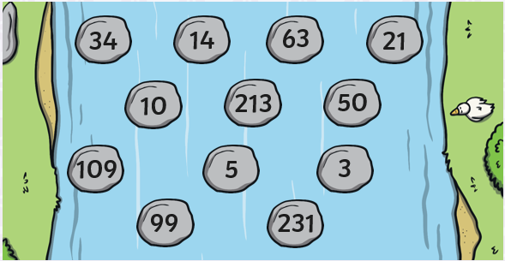  What is the largest number you can make crossing the stream?  What is the smallest number you can make crossing the stream?  Can you find a way to cross the stream using only odd numbers? What is your total when you get to the other side?
Topic Mission  Day 5 | By the end of this mission, children will have made their own worry monster. Worry monsters are friendly monsters that nibble up worries and make them go away!  Part 4: Today the children need to complete the evaluation sheet below. This could be printed or used as a guide for them to consider the answers and think about what went well and what could have been improved when making their worry monster.

