Reading Day 3 & 4

Extract from Charlie and the Chocolate Factory by Roald Dahl

Only once a year, on his birthday, did Charlie Bucket ever get to taste a bit of chocolate. The whole family saved up their money for that special occasion, and when the great day arrived, Charlie was always presented with one small chocolate bar to eat all by himself. And each time he received it, on those marvellous birthday mornings, he would place it carefully in a small wooden box that he owned, and treasure it as though it were a bar of solid gold; and for the next few days, he would allow himself only to look at it, but never to touch it. Then at last, when he could stand it no longer, he would peel back a tiny bit of the paper wrapping at one corner to expose a tiny bit of chocolate, and then he would take a tiny nibble – just enough to allow the lovely sweet taste to spread out slowly over his tongue. The next day, he would take another tiny nibble, and so on, and so on. And in this way, Charlie would make his sixpenny bar of birthday chocolate last him for more than a month.

But I haven’t yet told you about the one awful thing that tortured little Charlie, the lover of chocolate, more than anything else. This thing, for him, was far, far worse than seeing slabs of chocolate in the shop windows or watching other children munching bars of creamy chocolate right in front of him. It was the most terrible torturing thing you could imagine, and it was this:

In the town itself, actually within sight of the house in which Charlie lived, there was an ENORMOUS CHOCOLATE FACTORY!

Just imagine that!

And it wasn’t simply an ordinary enormous chocolate factory, either. It was the largest and most famous in the whole world! It was WONKA’S FACTORY, owned by a man called Mr Willy Wonka, the greatest inventor and maker of chocolates that there has ever been. And what a tremendous, marvellous place it was! It had huge iron gates leading into it, and a high wall surrounding it, and smoke belching from its chimneys, and strange whizzing sounds coming from deep inside it. And outside the walls, for half a mile around in every direction, the air was scented with the heavy rich smell of melting chocolate!

Twice a day, on his way to and from school, little Charlie Bucket had to walk right past the gates of the factory. And every time he went by, he would begin to walk very, very slowly, and he would hold his nose high in the air and take long deep sniffs of the gorgeous chocolatey smell all around him.

Oh, how he loved that smell!

And oh, how he wished he could go inside the factory and see what it was like!

Wednesday 1st April

|  |  |
| --- | --- |
| **Reading Mission**  30 mins | Children to read or be supported to read the extract from Charlie and the Chocolate Factory.  **After they can answer these questions, these can be verbal answers or they could be written down or typed. Suggested answers are in italics.**   1. When does Charlie get to taste chocolate? *Once a year on his birthday.* 2. Who bought the chocolate for Charlie? *His family* 3. How do you think Charlie feels when he is given his bar of chocolate? 4. Where does Charlie keep the chocolate? *In a small wooden box* 5. Why do you think Charlie didn’t eat the chocolate straight away? *He wanted to make it last as he only gets one small bar a year.* 6. How much did the bar of chocolate cost? *Six pennies* 7. Which word or words tell us that Charlie found it really hard living so close to the chocolate factory? *It was the most terrible torturing thing you could imagine.* 8. How would you feel if you lived right next to a chocolate factory? 9. Who owned the chocolate factory? *Mr Willy Wonka* |
| Writing Mission  30 mins | Today’s writing mission links to your reading text Charlie and the Factory.  Your mission is to invent a new sweet for Mr Willy Wonka.   1. You will need to come up with a new sweet or chocolate that is interesting enough for Mr Wonka. Mr Wonka’s sweets have a special feature. They contain a surprise or perform a function. Yours will need to do the same. For example, a sweet to make people laugh. 2. Once you have decided on your sweet/chocolate you will need to give it a name and a description. Roald Dahl was a master of inventing new words. Try combining words to create a name for your sweet. E.g. Fizzblasters. Some wow words – fizzy, delicious, melt, pop, blast.   An inventive product like yours deserves exciting packaging. Include tempting words and adjectives to persuade people to try it. Make it eye catching with large writing, pictures and lots of colours. |
| Maths Mission  30 mins | How quickly can you complete the monster maths subtraction challenge? There are 3 levels of challenge. Choose the right level of challenge for you.  See activity sheets below. |
| Topic Mission Day 3 | By the end of this mission, children will have made their own worry monster. Worry monsters are friendly monsters that nibble up worries and make them go away!  Part 2: Today the children will use their designs to start to gather materials and begin to make their worry monster. We have left 2 days for this activity as it may be something the children wish to come back to over a couple of days or they may do it all in one afternoon! Remember your design criteria: the monster must be able to be placed in my bedroom, it must be able to take or listen to my worries (a hole or slot perhaps).  Remember, the monsters could be make from junk modelling and recycling from around the house, a picture they have designed and coloured and then cut out, use of basics at home such as a plastic cup or tissue box or they could get creative and sew something. Use whatever is available to you and your household. |

Monster Maths Challenge 1

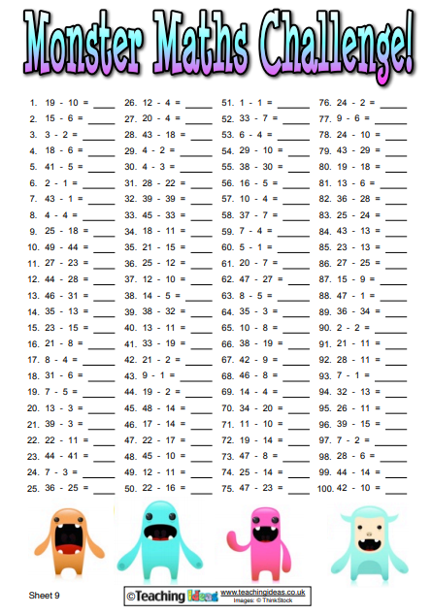

Monster Maths Challenge 2

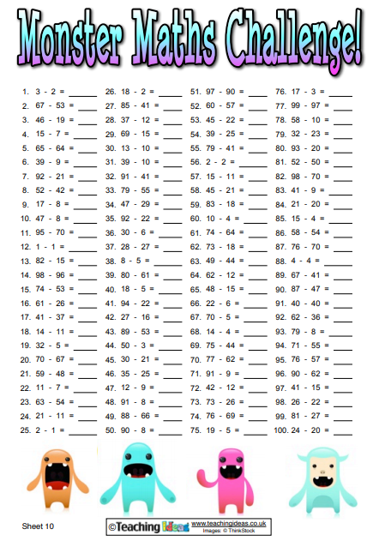

Monster Maths Challenge 3

