Timetable 1st April March 2020

Reading Mission:  30 minutes | Children to read or support them to read this short text:  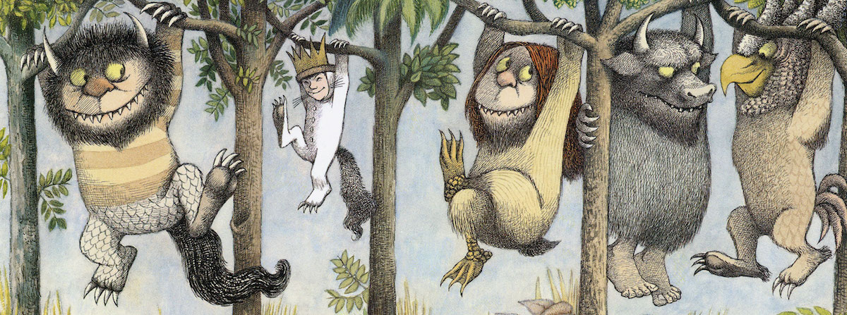  ‘Where the Wild Things Are’  And when he came to the place where the wild things are they roared their terrible roars and gnashed their terrible teeth and rolled their terrible claws until Max said “BE STILL!” and tames them with a magic trick of staring in to their yellow eyes without blinking once and they were frightened and called him the most wild thing of all and made him king of all the wild things. “And now”, cried Max “let the wild rumpus start!”  “Now stop!” Max said and sent the wild things off to bed without their supper. And Max the king of all wild things was lonely and wanted to be where someone loved him best of all.  Then all around from far away across the world he smelled good things to eat so he gave up being king of where the wild things are. But the wild things cried, “Oh please don’t go – we’ll eat you up-we love you so!”  And Max said, “No!”  The wild things roared their terrible roars and gnashed their terrible teeth and rolled their terrible eyes and showed their terrible claws but Max stepped in to his private boat and waved good-bye. He sailed back over a year and in and out of weeks and through a day and in to the night of his very own room where he found his supper waiting for him.  After they can answer these questions, these can be verbal answers or they could be written down or typed. Children could even draw their responses. Suggested answers are in italics.  What sound do the wild things make?  They roared terrible roars.  Why is ‘’BE STILL’’ in capital letters?  It is in capitals because Max might be angry or shouting it.  How does Max tame the wild things?  By staring into their yellow eyes without blinking.  What did Max cry out?  ‘And now, let the rumpus start’  Can you define the word ‘supper’? Can you think of a synonym?  Supper means dinner or when you would eat in the evening and you could say dinner, tea, evening meal or main meal.  Can you find three adjectives used to describe the wild things?  Terrible claws, terrible teeth, yellow eyes, terrible eyes.  When Max felt lonely, where did he want to be? What might that mean?  Somewhere where someone loved him best of all. This may mean at home with his family and friends, at his favourite place or somewhere he feels happy and safe.  Can you spot different punctuation in this story? What is it used for? Speech marks – identifies when someone is speaking. Exclamation mark – used in an exclamation sentence or to show emotion. Full stop – shows the end of a sentence. Commas – used in lists or in a sentence to make it clear.
Writing Mission:  30 minutes | 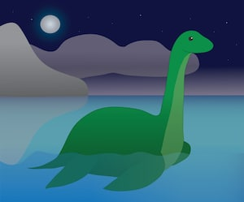  Your mission today is to use the poster about the Loch Ness Monster you created yesterday and the information sheet alongside it to create a piece of writing (about two paragraphs long). You may want to research more information on the Loch Ness Monster on a phone, tablet or computer if you can. (There is a small information sheet at the bottom of today’s timetable)  Your piece of writing could be:  - A description of the Loch Ness Monster  - A story about the Loch Ness Monster  - A persuasive piece of writing about whether you think the Loch Ness Monster is real or not real and why.  Make sure you use expanded noun phrases (two or more adjectives using a comma), suffixes (such as words using ‘ing’ ‘est’ ‘er’ and ‘ed’), and exclamation sentence (has to start with what or how and end with an exclamation mark such as ‘What a crazy monster he is!’)
Maths Mission:  30 minutes | Uh oh. Some of the monsters want to buy the cakes that other monsters have made. Can you help the monsters to work out what coins they could use to pay for the different cakes? You must think of two ways per cake.  Example: Chocolate birthday cake is 50p:  You could pay with five 10ps (10p + 10p + 10p + 10p + 10p = 50p)  or two 20ps and a 10p (20p + 20p = 10p = 50p).  (A coins poster to support this activity is posted below the timetable)  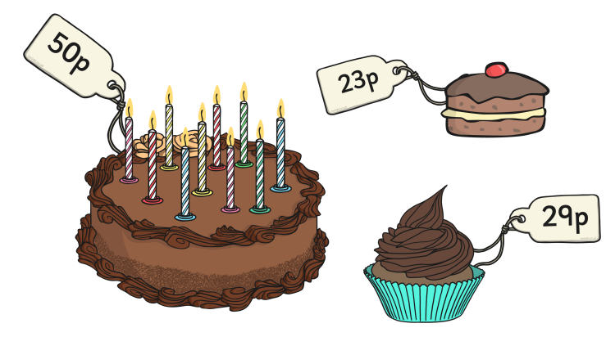  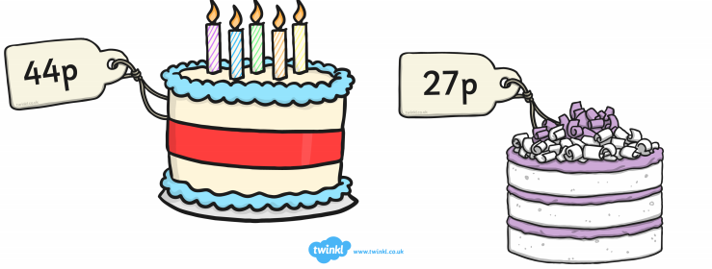  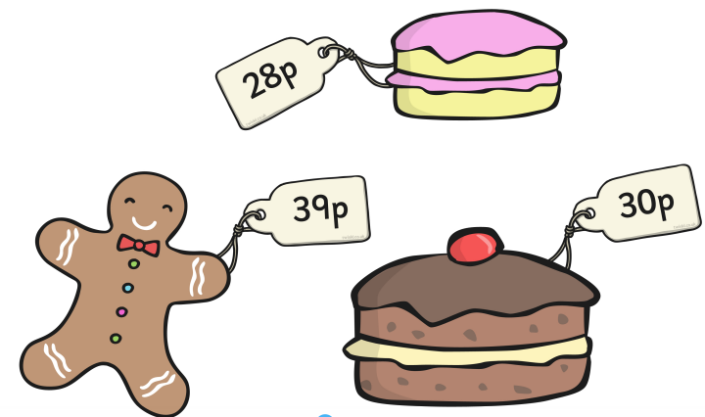  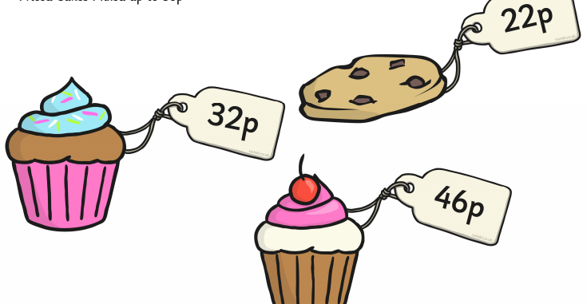
Topic Mission:  Day 3 | 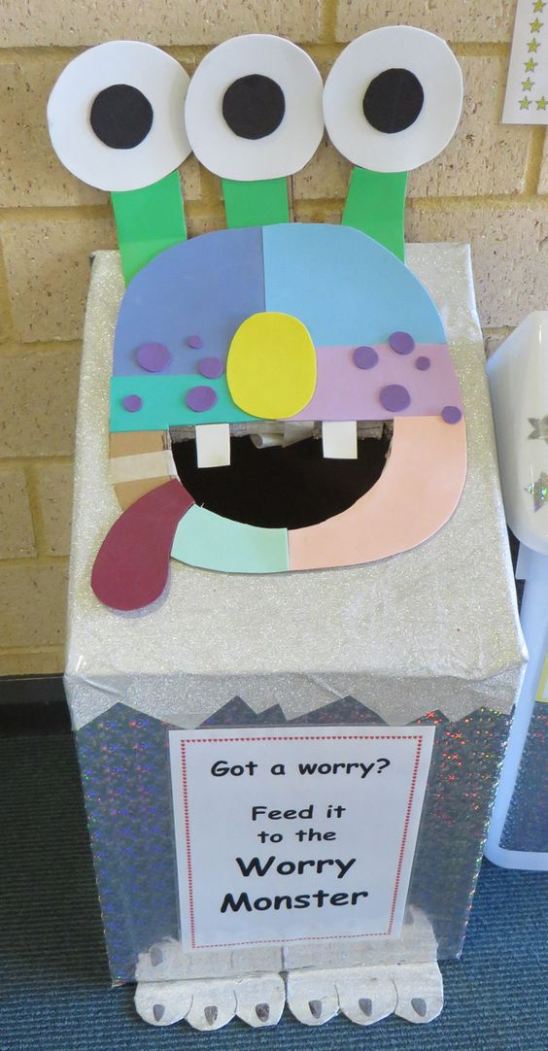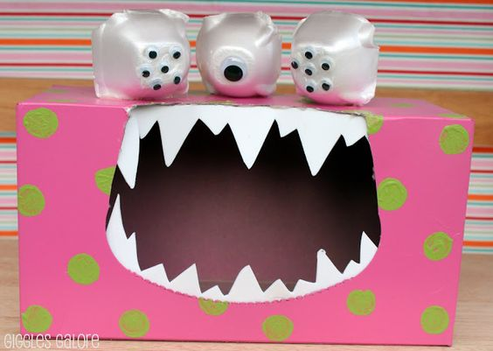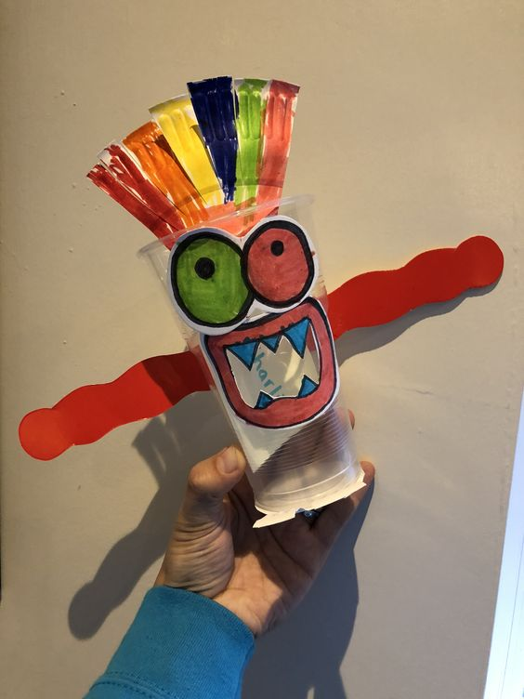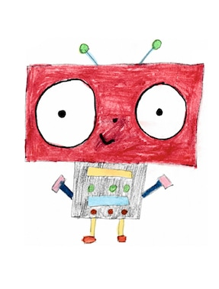  By the end of this mission, children will have made their own worry monster. Worry monsters are friendly monsters that nibble up worries and make them go away!  Part 2: Today the children will use their designs to start to gather materials and begin to make their worry monster. We have left 2 days for this activity as it may be something the children wish to come back to over a couple of days or they may do it all in one afternoon! Remember your design criteria: the monster must be able to be placed in my bedroom, it must be able to take or listen to my worries (a hole or slot perhaps).  Remember, the monsters could be make from junk modelling and recycling from around the house, a picture they have designed and coloured and then cut out, use of basics at home such as a plastic cup or tissue box or they could get creative and sew something. Use whatever is available to you and your household.
These Missions have been designed to be accessible, using little resources and most importantly fun for your children to complete. Please use what you can, any resources you do not have could be substituted for something else and suggestions have been made for this where possible.

Sheets if needed:



