Timetable 30th March 2020

Reading Mission:  30 minutes | Phonics-based Warmup! (First see Home Learning Reading and Writing PowerPoint)  Ask children to copy down these words and add buttons and zips, then read them! A button is a dot and goes under a single letter that makes one sound e.g. (b,d,s,p). A zip is a line and it goes under a digraph or a trigraph (two or three letters that make one sound e.g. (ee, igh, sh, ch, th, ay, ea).  playground  trolley  outside  supermarket  rainbow  cupcake  Reading Comprehension  Children to read or support them to read this short story:  One sunny morning, Dan went to the supermarket with his mum to get some ingredients to bake cupcakes. On the way there, they stopped at a playground and Daniel swung on the swings and slid down the slide as quickly as he could. When they got to the supermarket, Dan got a trolley from outside. They went into the supermarket and put eggs, flour, sugar, butter and some chocolate chips into the trolley and paid for them at the checkout. When they went back outside, they saw an amazing rainbow in the sky and they both smiled.  After they can answer these questions, these can be verbal answers or they could be written down or typed. Children could even draw their responses. Suggested answers are in italics. Encourage full sentence answers.  Who went to the supermarket?  What did Dan do in the playground?  Can you name three things that Dan put into his trolley?  Why did Dan and his mum smile when they came back out of the supermarket?  What do you think will happen next?
Writing Mission:  30 minutes | 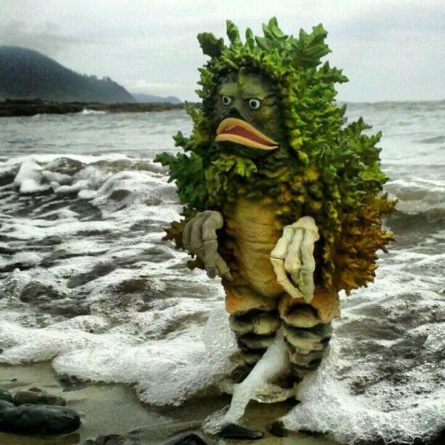  Can you write a character description of this monster? Describe what he looks like, how he behaves, where he has come from, and what he likes.  See if you can use different items from the toolkit, like a word with an un- prefix, an expanded noun phrase, an exclamation mark, or a conjunction like and or because in one of your sentences.  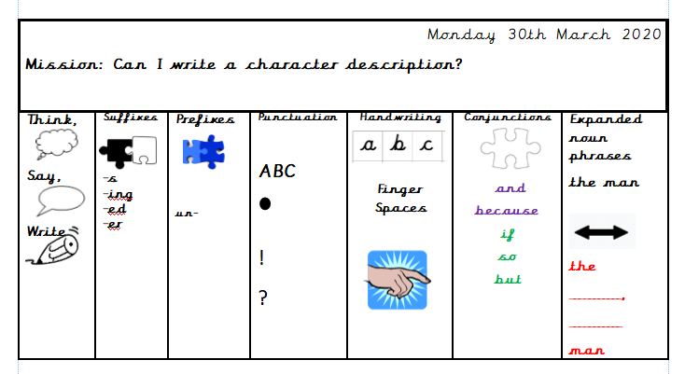  Example on the next page.  Example:  The monster has green, spiky leaves all over his back and around his head like a mane. He has long, white claws for hands. His lips are long and thick, his eyes are small and round, and his mouth curves down into a grimace when he sees people dropping rubbish on the beach. He loves to body surf on the powerful, crashing waves and he lives in a cave under the sea.  He looks quite frightening but he is not an unkind monster. In fact, he lets birds and insects live in his leafy mane and uses his claws to tickle the tiny, colourful fish in the sea so that they can have a laugh! He also uses his claws to scoop up any litter from the beach because he cares about the environment.
Maths Mission:  30 minutes | Do Now: Practise counting in 1’s from 0 all the way to 50.  A good video for practising counting in 1’s-https://www.youtube.com/watch?v=YtNskltyA0E  Today you are going to practise counting and writing numbers to 50. Make sure you check that you are forming your numbers correctly! There us a number mat available in the home learning folder to help you.  Start by practicing writing your numbers from 0-10. Use this picture to make sure you are writing each number the right way round.  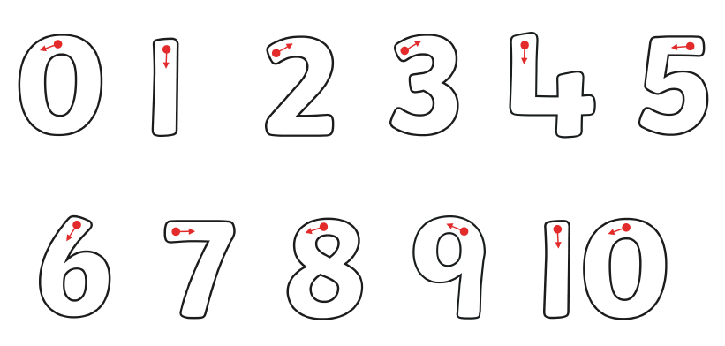  Mission 1:  Using objects you can find in your house or garden see how many ways you can correctly write or build numbers from 0-10. For example, you might want to build each number out of Lego or sprinkle flour onto a flat surface and use your finger as a pencil. I have attached a few ideas underneath but this activity is designed for children to get as creative as they like! You might even want to use your IT skills we have learnt at school to take a picture of your numbers.  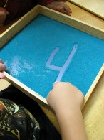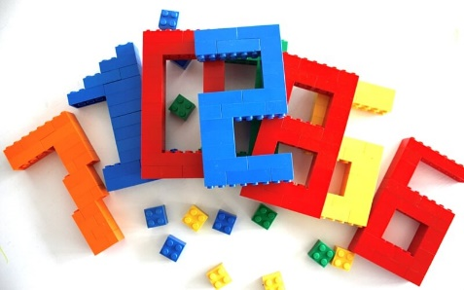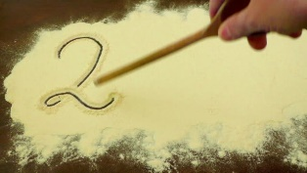  Mission 2: Can you complete these number sequences?  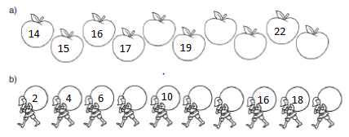  Challenge: can you count backwards from 50-0?
Topic Mission:  Day 1 | Mission: Can I design a purposeful product based on a design criteria?  By the end of this mission, children will have made their own worry monster. Worry monsters are friendly monsters that nibble up worries and make them go away!  Part 1 of this mission is to design and label a plan of their worry monster.  Design criteria: the monster must be able to be placed in my bedroom, it must be able to take or listen to my worries (a hole or slot perhaps).  Get children to consider these questions:  What materials will I need to make it?  What colours will I need and why have I chosen these colours?  What shape could my monster be and why?  How big or small will my monster be?  How can I make my worry monster appealing to me? Will it be my favourite colour, funny looking or covered in my favourite things?  Get children to draw or sketch out their worry monster on a piece of paper and label the parts of their worry monster considering the questions above. Some pictures below are just ideas!  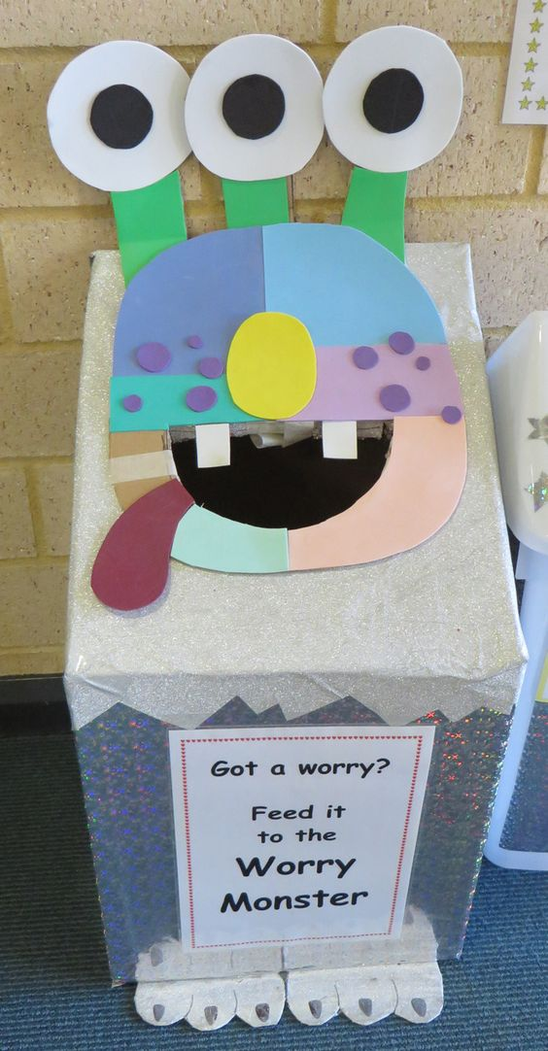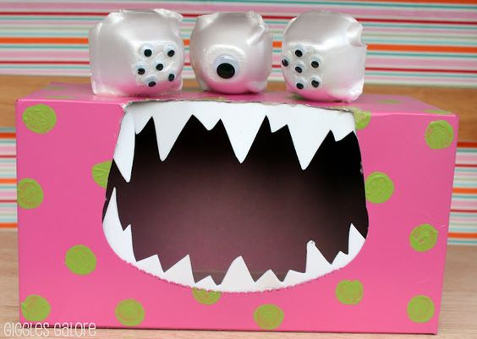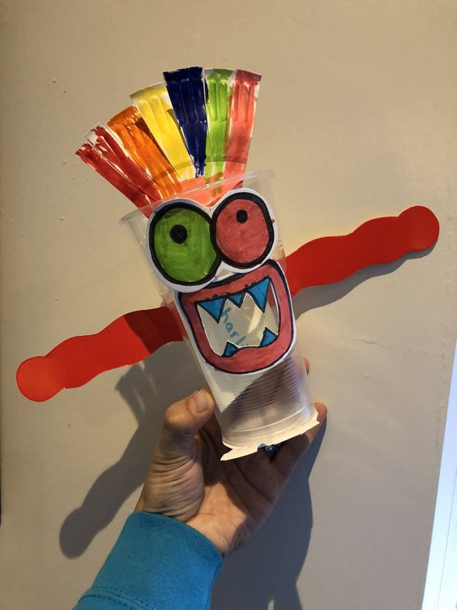
These Missions have been designed to be accessible, using little resources and most importantly fun for your children to complete. Please use what you can, any resources you do not have could be substituted for something else and suggestions have been made for this where possible.

